INCEPTION REPORT
Development of a Containerized Ecommerce & Services Platform
for Cloud Sphere Solutions, Kigali
SPEDO501 Perform DevOps · Year 3 SPE Capstone · 2026–2027
Document title | Inception Report — Cloud Sphere Ecommerce Platform
Document ID | CSS-INC-2026-001
Milestone | M1 — Inception + SRS baseline (Week 1–2)
Client | Cloud Sphere Solutions | Kicukiro District, Kigali
Programme | SPEDO501 · ICTSPE5002 · Rwanda Coding Academy Year 3 SPE
Delivery team | Year 3 SPE project group · Trainer / tech lead: Stanley Mwizerwa
Authoritative requirements | SRS CSS-SRS-2026-001 v1.0 (baselined with this report)
Acceptance instrument | UAT Test Pack CSS-UAT-2026-001 v1.0 (executed at M3/M5)
Version / date | v1.0 · 20 September 2026
Status | SUBMITTED — pending Cloud Sphere Product Owner & trainer acceptance

Table of Contents
- 1 Executive summary
- 2 Project background and programme context
- 3 Scope of work
- 4 Project organisation and team
- 5 Development methodology (including SRS/UAT binding)
- 6 Technical architecture overview
- 7 Project work plan, Gantt and milestones
- 8 Effort and resources
- 9 Communication and reporting
- 10 Risk register
- 11 Quality and UAT approach
- 12 Assumptions and dependencies
- 13 Immediate next steps
- Annex A Gantt · Annex B Document set

1. Executive summary
This Inception Report marks the formal commencement of the Cloud Sphere Solutions Ecommerce Platform as Milestone 1 of the SPEDO501 integrated capstone. The project will deliver a secure, containerized ecommerce platform consisting of a web storefront, REST API, and database service, supported by an automated CI/CD pipeline and operational monitoring through logging, dashboards, and alerts. The project will be delivered over 19 weeks and 80 hours, with work structured across five assessment milestones covering development, testing, acceptance, and operational readiness.
The project is governed by three complementary baselines: SRS CSS-SRS-2026-001, which defines what the platform must deliver; UAT Pack CSS-UAT-2026-001, which defines how the completed product will be validated and accepted; and this Inception Report, which defines how the project will be planned, controlled, and delivered. Together, they establish clear traceability from requirements through implementation and testing to final acceptance. The agreed scope is focused on the web-based ecommerce platform, with native mobile application development and testing outside the project scope. This baseline provides the foundation for controlled delivery, measurable quality, and successful acceptance of the Cloud Sphere platform.

2. Project background and programme context
Cloud Sphere Solutions is developing a containerized ecommerce platform consisting of a web storefront, REST API, and database service, supported by CI/CD, automated testing, logging, dashboards, and alerts. The project covers the full software delivery lifecycle, from requirements and design through development, testing, deployment, and user acceptance.
The project is part of the SPEDO501 integrated capstone within the Rwanda Coding Academy Year 3 SPE programme and will be delivered over 19 weeks / 80 hours across five assessment milestones. The project is guided by the SRS, which defines system requirements, the UAT Pack, which defines acceptance criteria and testing, and this Inception Report, which establishes the delivery scope, plan, risks, assumptions, and governance.

3. Scope of work
The Cloud Sphere Ecommerce Platform project covers the design, development, testing, deployment, and operational setup of a containerized web-based ecommerce system. The main scope includes the web storefront, REST API, and database service, together with CI/CD automation, functional and security testing, User Acceptance Testing, logging, dashboards, and alerts. The project will also include the necessary documentation and configuration required to deploy, operate, and validate the platform.

3.1 In Scope
- Web-based ecommerce storefront.
- REST API and backend services.
- Database service and data management.
- Containerized application environment.
- CI/CD pipeline for build, test, and deployment.
- Functional, integration, and security testing.
- User Acceptance Testing (UAT).
- Logging, dashboards, and operational alerts.
- Technical and project documentation.

3.2 Out of Scope
- Native Android or iOS mobile applications.
- Features or integrations not defined in the approved SRS.
- Major changes to requirements after the SRS baseline without formal change control.
- Long-term production support beyond the agreed project period.
The detailed functional and security requirements are defined in SRS CSS-SRS-2026-001, while product acceptance is governed by UAT Pack CSS-UAT-2026-001. Any work outside the scope defined by these baselines requires formal review and approval.

4. Project organisation and team

4. Project Organisation and Team
The Cloud Sphere Ecommerce Platform will be delivered by the Year 3 SPE project group under the guidance of the trainer and technical lead. The team will work collaboratively across requirements analysis, software development, testing, DevOps, documentation, and project coordination to ensure that the agreed scope and quality requirements are met.
Role | Responsibility
Client / Product Owner | Provides business requirements, reviews deliverables, provides feedback, and participates in UAT and final acceptance.
Trainer / Technical Lead – Stanley Mwizerwa | Provides technical guidance, reviews project progress, and supports compliance with programme and technical requirements.
Project Team | Designs, develops, tests, documents, and deploys the ecommerce platform according to the approved SRS.
Development / Backend Team | Implements the web application, REST API, database integration, and business logic.
DevOps / Infrastructure Team | Manages containerization, CI/CD, deployment, logging, dashboards, and alerts.
Testing / QA Team | Develops and executes tests, records defects, verifies fixes, and supports UAT preparation and execution.
Documentation / Project Coordination | Maintains project documentation, schedules, requirements traceability, risks, and milestone deliverables.

The team will use a collaborative workflow with regular reviews and progress tracking. Responsibilities may overlap where necessary, but all major deliverables will have identified owners to maintain accountability, traceability, and quality throughout the project lifecycle.

5. Development methodology

5.1 Sprint Structure (Mapped to the Scheme of Work)
The project will be delivered using an iterative sprint-based approach aligned with the SPEDO501 scheme of work and the five assessment milestones. The 19-week / 80-hour schedule is divided into planned delivery stages, with each stage producing measurable outputs and contributing to the final ecommerce platform.
Stage | Main Focus | Key Outputs
Milestone 1 | Inception and requirements | Inception Report, baselined SRS, project plan
Milestone 2 | Architecture and initial development | System architecture, containers, database and initial application components
Milestone 3 | Core implementation and testing | Functional ecommerce features, API integration, automated tests
Milestone 4 | Integration and operational readiness | CI/CD, logging, dashboards, alerts, security and integration testing
Milestone 5 | Acceptance and final delivery | UAT execution, defect resolution, final documentation and sign-off
Each sprint will begin with a review of the prioritized work and end with a review of completed outputs. Requirements and priorities will be tracked against the approved SRS to maintain traceability throughout development.

5.2 Ceremonies and Artifacts
The team will use lightweight Agile practices to coordinate work, monitor progress, and maintain quality. Regular planning, stand-up, review, and retrospective activities will be used throughout the project.
Key project artifacts will include the product backlog, sprint backlog, requirements traceability records, source code, CI/CD configuration, test cases and results, defect records, risk register, project documentation, and UAT evidence. These artifacts provide evidence of progress and support traceability from the approved requirements through implementation, testing, and final acceptance.

5.3 How this report, the SRS and UAT fit together
The three documents serve different but connected purposes throughout the project lifecycle. This Inception Report defines how the project will be planned, managed, and delivered, including the scope, schedule, technical approach, risks, assumptions, and milestones. The SRS CSS-SRS-2026-001 defines what the system must deliver, including its functional, security, and other technical requirements. The UAT Pack CSS-UAT-2026-001 defines how the completed system will be validated and accepted by providing executable test cases, acceptance metrics, and sign-off criteria.
Together, they provide a clear traceability chain:
Inception Report → SRS → Implementation → Testing → UAT → Acceptance
The Inception Report provides the project framework, the SRS provides the authoritative requirements baseline, and the UAT Pack provides the acceptance mechanism. Any implementation or testing activity must remain consistent with these approved baselines, while changes to the agreed requirements or scope must follow the project's change-control process.

6. Technical architecture overview
The Cloud Sphere Ecommerce Platform will use a containerized, service-oriented architecture consisting of three primary application components: a web storefront, a REST API, and a database service. The web storefront will provide the user-facing ecommerce interface, while the REST API will handle business logic, authentication, data processing, and communication with the database. The database service will provide persistent storage for application data.
The services will be packaged and managed using containers, providing consistency between development, testing, and deployment environments. A CI/CD pipeline will automate the build, testing, and deployment process, helping to identify defects early and maintain repeatable releases. The platform will also include logging, dashboards, and alerts to support monitoring and operational visibility. Security controls and automated testing will be incorporated throughout the development lifecycle, with final functionality and acceptance validated against the approved SRS and UAT Pack.

High-Level Architecture
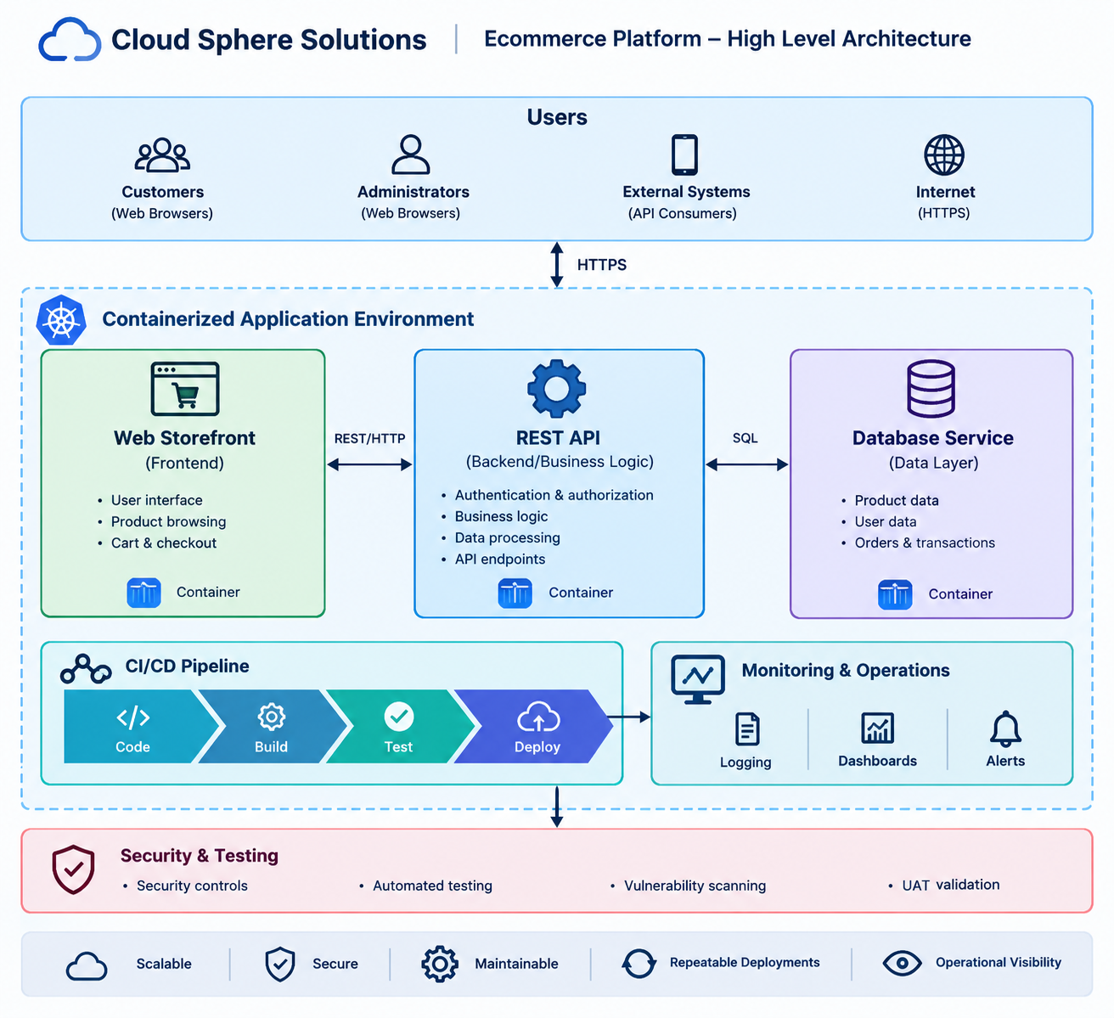
The architecture is designed to support maintainability, repeatable deployment, testability, security, and operational visibility while remaining appropriate to the project's scope and available delivery time. Detailed technology choices, interfaces, configurations, and deployment specifications will be maintained in the relevant technical documentation.

7. Project work plan and schedule
The Cloud Sphere Ecommerce Platform will be delivered over 19 weeks, from 29 September 2026 to 8 February 2027, with a total planned effort of 80 hours. The work will follow an iterative sprint-based approach and will be organized around five assessment milestones. Each milestone produces defined outputs that contribute to the final platform, while progress will be monitored against the project schedule, SRS, risks, and acceptance requirements.
Milestone | Dates | Main Activities | Key Deliverables
M1 – Inception & SRS Baseline | 29 Sep – 12 Oct 2026 | Project initiation, requirements review, planning, scope and risk definition | Inception Report, SRS baseline, project plan
M2 – Architecture & Foundation | 13 Oct – 9 Nov 2026 | Architecture, database setup, containerization, initial frontend and API development | Architecture, database, containerized foundation
M3 – Core Development & Testing | 10 Nov – 7 Dec 2026 | Ecommerce features, API integration, functional and automated testing | Working platform, test results, defect records
M4 – Integration & Operations | 8 Dec 2026 – 11 Jan 2027 | CI/CD, security testing, logging, dashboards, alerts, integration testing | CI/CD pipeline, monitoring, security and integration evidence
M5 – UAT & Final Delivery | 12 Jan – 8 Feb 2027 | UAT execution, defect resolution, final validation, documentation and handover | UAT results, final documentation, acceptance/sign-off

The schedule is intended to provide a controlled progression from project initiation and requirements through architecture, implementation, testing, operational readiness, and final acceptance. Sprint activities will be reviewed regularly against the planned dates and deliverables. Any changes affecting the approved scope, requirements, milestones, or acceptance criteria will be managed through the project's change-control process.

7.1 Milestone acceptance criteria

7.1 Milestone Acceptance Criteria
Each project milestone will be considered complete when its planned deliverables have been produced, reviewed, and verified against the applicable requirements and quality criteria. Acceptance will be based on objective evidence rather than completion of activities alone.
Milestone | Acceptance Criteria
M1 – Inception & SRS Baseline | Inception Report completed and reviewed; SRS CSS-SRS-2026-001 baselined; project scope, schedule, risks, assumptions, and delivery approach documented and approved.
M2 – Architecture & Foundation | Architecture documented; web, API, and database components established; services successfully containerized; initial integration demonstrated; foundation reviewed against the approved SRS.
M3 – Core Development & Testing | Core ecommerce functionality implemented according to the SRS; API and database integration working; planned functional and automated tests executed; identified defects recorded and tracked.
M4 – Integration & Operations | CI/CD pipeline operational; application successfully builds and deploys; security and integration testing completed; logging, dashboards, and alerts configured and demonstrated.
M5 – UAT & Final Delivery | UAT Pack CSS-UAT-2026-001 executed; acceptance metrics met; critical defects resolved or formally accepted; final documentation completed; product owner and trainer/technical lead sign-off obtained.

Milestone acceptance will require documented evidence such as reports, test results, screenshots, CI/CD records, logs, and UAT results where applicable. Any outstanding issues that prevent acceptance will be recorded and managed through the project’s defect or change-control process.

8. Effort and resources

8. Effort and Resources
Resource / Budget Line | Allocation | Notes
Contact hours | 80 hours | 5 hours/week × 16 teaching weeks, with additional project/CAT/examination structure as defined by the programme.
Learning outcomes | LO1: 30 h / LO2: 20 h / LO3: 20 h / LO4: 10 h | Effort is distributed according to the SPEDO501 scheme of work.
Team size | 3–5 trainees per Cloud Sphere group | Roles defined in Section 4 may rotate where the team is small.
Compute resources | Lab PCs + AWS Free Tier or local kind/minikube | Cloud resources will be used within available limits. No production expenditure without trainer approval.
Development tools | GitHub/GitLab, Docker, Kubernetes, JMeter/Gatling, Grafana stack, Jira/Issues | Tools will support source control, containerization, testing, monitoring, and project tracking.
Testing resources | Automated and manual testing environments | Testing will cover functional, integration, security, performance, and UAT activities as applicable.
UAT participants | ≥ 2 shoppers + 1 administrator + Product Owner | Participants performing acceptance should not be the same people who implemented the specific functionality being accepted.
Documentation | Digital project repository and controlled project documents | Includes the Inception Report, SRS, test evidence, UAT results, technical documentation, and final deliverables.
Human resources | Project team + trainer/technical lead + Product Owner | The project team performs implementation and testing, while the trainer and Product Owner provide technical review and acceptance oversight.

Resource usage will be monitored throughout the project to ensure that the planned 80-hour effort and available technical resources remain aligned with the five project milestones. Any additional infrastructure costs or significant resource requirements must be identified and approved before they are incurred.

9. Communication and reporting
Effective communication will be maintained throughout the project to ensure that the Cloud Sphere Solutions Product Owner, trainer/technical lead, and project team remain aligned on progress, issues, risks, and deliverables. Communication will be focused on timely decision-making, requirements clarification, and milestone acceptance.
Communication / Report | Frequency | Participants / Owner | Purpose
Team stand-up | Weekly / per sprint | Project team | Review progress, tasks, blockers, and priorities.
Sprint review | End of each sprint | Team, Product Owner, trainer | Demonstrate completed work and collect feedback.
Sprint retrospective | End of each sprint | Project team | Identify improvements and address process issues.
Progress report | At each milestone | Project team → Product Owner / trainer | Report completed work, issues, risks, and upcoming activities.
Risk and issue review | Ongoing / weekly | Project team | Identify, assess, and track project risks and issues.
UAT reporting | During M5 | QA team, Product Owner, trainer | Record test results, defects, acceptance metrics, and sign-off status.
Final project report | M5 | Project team | Summarize implementation, testing, outcomes, and final acceptance.

Project communication and evidence will be maintained through the agreed collaboration and project-management tools, including GitHub/GitLab and Jira/Issues where applicable. Major decisions, requirement changes, risks, and acceptance outcomes will be documented to maintain traceability and provide an auditable project record.

10. Risk register
Risks will be reviewed throughout the project and updated as new threats, constraints, or issues are identified. Likelihood (L) and Impact (I) are assessed as Low (L), Medium (M), or High (H).
ID | Risk | L | I | Mitigation
R01 | UAT environment is not smoke-tested before execution, resulting in wasted test time or failed demonstrations. | M | H | Make the smoke-test checklist a mandatory UAT entry criterion. The UAT environment must be verified before Lab 4/UAT execution begins.
R02 | Payment timeout after a transaction is marked as paid may create inconsistent payment and stock states. | M | H | Implement and test the payment timeout behaviour defined in FR-PAY-03 and UAT CO-011, including clear transaction-state handling.
R03 | Native mobile applications or real Mobile Money charges are introduced into the project scope. | M | H | Maintain the approved out-of-scope list across the Inception Report, SRS, and UAT documentation. Use a payment stub/adapter rather than live payment processing.
R04 | Excessive reliance on end-to-end testing results in a slow, unreliable CI/CD pipeline with insufficient unit-level coverage. | H | M | Apply a testing pyramid with unit tests, integration tests, and targeted E2E tests. Enforce the testing stage in the CI/CD pipeline and apply TDD practices where appropriate.
R05 | REQ-WL-06 is not covered or verified in the Requirements Traceability Matrix (RTM). | M | H | Run rtm_gaps.py during Week 9 to identify missing coverage and verify the requirement against UAT WO-006 before acceptance testing.
R06 | Lab environments do not have sufficient cluster resources or required container tooling such as Docker/Kubernetes. | M | M | Perform a technical environment dry-run during Week 2. Maintain a documented Compose-only fallback where Kubernetes resources are unavailable.
R07 | UAT participants are also the developers responsible for the feature being accepted, reducing independence of acceptance testing. | H | M | Use cross-group Product Owner role-play for UAT and require the trainer to act as a second reviewer/signer where applicable.
R08 | Personally identifiable or sensitive information, such as passwords or Mobile Money PINs, is written to application logs. | L | H | Apply the controls defined in SEC-08 and AU-010. Review logs during UAT against NF-006 and ensure sensitive values are masked or excluded.

Risk Management Approach
The project team will review the risk register regularly, particularly at sprint reviews and milestone checkpoints. High-impact risks will receive priority attention and must have documented mitigation actions. New risks identified during development, testing, or UAT will be added to the register and assigned appropriate mitigation measures.
Risks that materialize will be managed as project issues, with their impact on scope, schedule, quality, security, and acceptance assessed and recorded.

11. Quality and UAT Approach
Quality will be managed throughout the project rather than only at the end of development. The team will use code reviews, automated testing, integration testing, security checks, CI/CD validation, and requirements traceability to identify defects early. Testing will follow an appropriate testing pyramid, combining unit, integration, and targeted end-to-end tests.
User Acceptance Testing will be conducted using UAT Test Pack CSS-UAT-2026-001, which provides the approved acceptance cases, metrics, and sign-off criteria. UAT will be performed in a smoke-tested environment by designated participants who are independent of the development of the specific functionality being accepted. UAT results, defects, evidence, and sign-off will be recorded and used to determine final acceptance.

12. Assumptions and Dependencies
The project is based on the following assumptions and dependencies:
Area | Assumption / Dependency
Requirements | The approved SRS remains the authoritative source for system requirements.
Scope | The project remains limited to the agreed web-based ecommerce platform; native mobile applications are excluded.
UAT | The UAT Pack remains the authoritative acceptance instrument and required participants are available.
Infrastructure | Lab computers and required containerization tools are available throughout the project.
Cloud resources | AWS Free Tier or equivalent resources may be used where appropriate, subject to availability and approval.
Team availability | Team members are available according to the 19-week project schedule and allocated 80-hour effort.
Product Owner | The Product Owner is available for requirements clarification, reviews, UAT, and acceptance decisions.
Technical guidance | The trainer/technical lead is available for technical review and milestone assessment.
Third-party services | External payment services will use approved stubs or test integrations rather than real financial transactions.
Change control | Changes affecting approved scope, requirements, schedule, or acceptance criteria will follow formal change control.

13. Immediate Next Steps
Following approval of the Inception Report and SRS baseline, the team will proceed with the following activities:
- Confirm project baselines — obtain confirmation of the Inception Report, SRS, scope, and UAT approach.
- Validate the development environment — confirm Git repository, Docker/container tooling, required dependencies, and available compute resources.
- Conduct the technical dry-run — verify that the planned containerization and deployment approach can operate within the available lab/cloud resources.
- Finalize the sprint backlog — translate the approved requirements into prioritized development tasks and assign responsibilities.
- Establish the CI/CD foundation — configure source control, automated build, test, and deployment stages.
- Begin architecture and foundation work — establish the database, API, web storefront, and containerized development environment.
- Maintain requirements traceability — ensure development and testing activities remain linked to the approved SRS requirements.
- Review risks and dependencies — confirm mitigation actions for the risks identified in the risk register and update them as the project progresses.

Annex A — Gantt overview
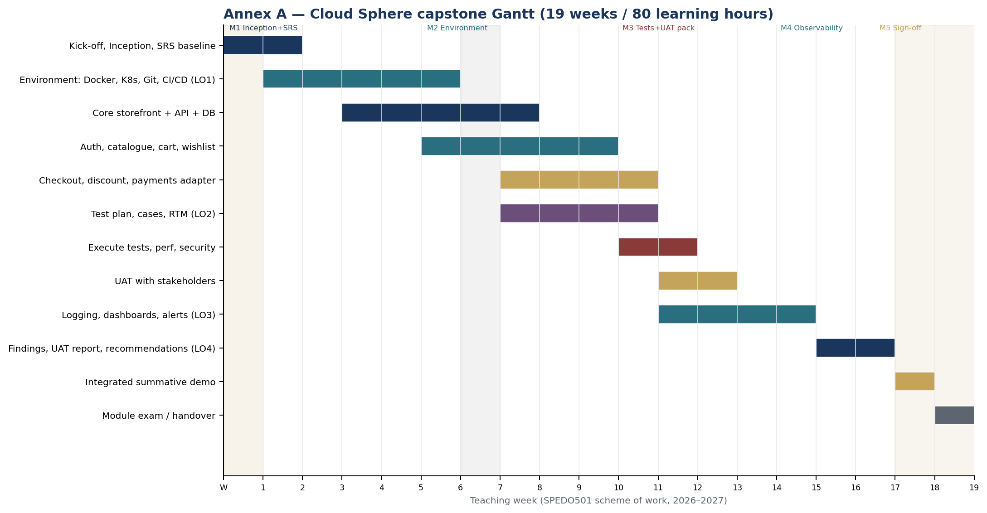
Figure A.1 — 19-week Gantt. M1–M5 markers match §7.1. Source: SPEDO501 scheme of work.
Shaded CAT week (W7) and exam week (W19) are assessment, not build. UAT is shown as a band in W12–W13 and again inside LO4 (W16), matching Goshen’s “UAT sign-off → milestone payment” idea, here translated to an academic gate.

Annex B — Document set
The following documents form the controlled document set for the Cloud Sphere Ecommerce Platform. Each document has a specific purpose and supports traceability from project planning and requirements through testing and final acceptance.
Document | Document ID / Version | Purpose | Status
Inception Report | CSS-INC-2026-001 v1.0 | Defines project scope, approach, schedule, risks, resources, governance, and delivery framework. | Baseline / Submitted
Software Requirements Specification (SRS) | CSS-SRS-2026-001 v1.0 | Defines functional, security, and non-functional system requirements and use cases UC-CS-01–13. | Baselined
Requirements Traceability Matrix (RTM) | Project-controlled | Links requirements to implementation and verification/testing evidence. | Maintained throughout project
UAT Test Pack | CSS-UAT-2026-001 v1.0 | Defines UAT cases, acceptance metrics, evidence requirements, and sign-off criteria. | Baseline / Executed at M3/M5
Project Gantt / Work Plan | Project-controlled | Defines the 19-week schedule, milestones, activities, and dependencies. | Controlled
Risk Register | Project-controlled | Records project risks, likelihood, impact, mitigation, and monitoring actions. | Maintained throughout project
Sprint Backlog | Project-controlled | Tracks prioritized development tasks and sprint commitments. | Updated per sprint
Test Evidence | Project-controlled | Provides evidence of functional, integration, security, automated, and other planned testing. | Produced throughout project
CI/CD Records | Project-controlled | Provides evidence of builds, automated tests, deployments, and pipeline execution. | Produced throughout project
Operational Evidence | Project-controlled | Provides evidence of logging, dashboards, alerts, and operational readiness. | Produced during M4
Final Project Report | Project-controlled | Summarizes implementation, testing, UAT, outcomes, lessons learned, and final delivery. | M5 deliverable

Document Control
The Inception Report, SRS, and UAT Test Pack form the primary project baselines. Controlled documents will be versioned when changes are approved, with superseded versions retained where required for traceability. Changes affecting requirements, scope, or acceptance criteria must be reviewed and approved through the project's change-control process.
The document set provides the following traceability chain:
Project Plan → Requirements → Implementation → Testing → UAT → Acceptance

